Vesting Prayers for the Clergy

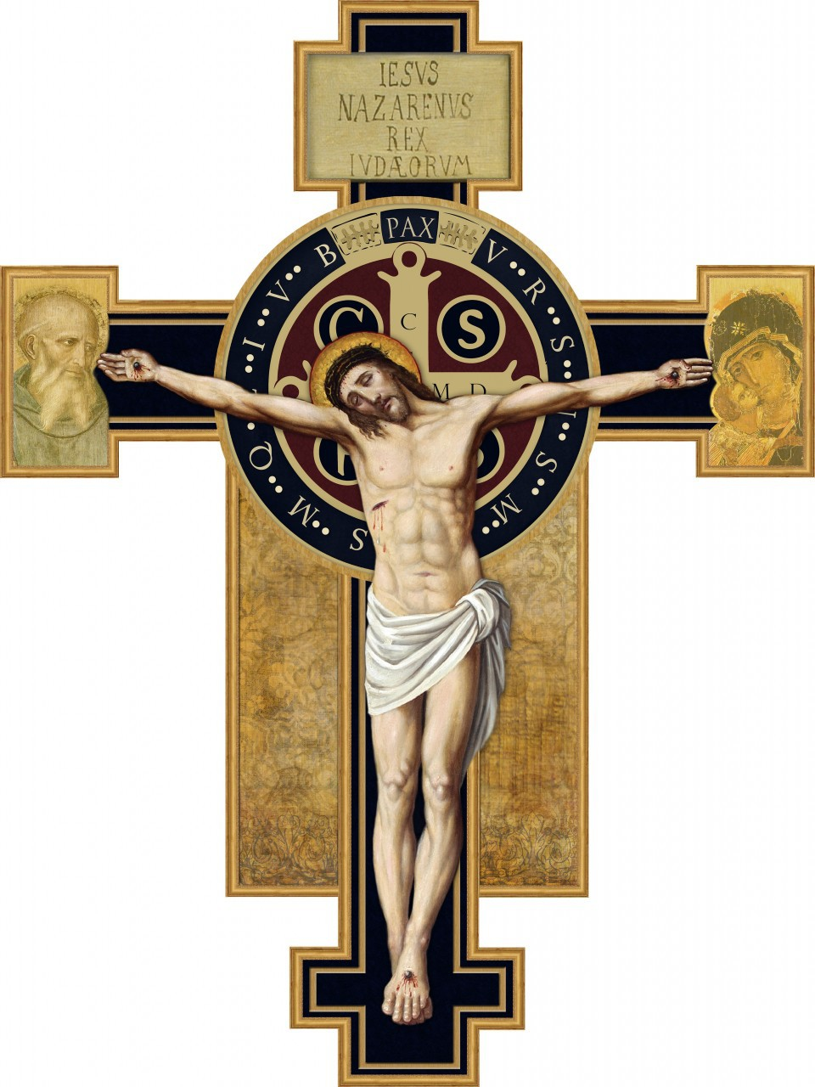
Before donning vestments, he or she prays while washing the hands:
Give virtue to my hands, O Lord, that being cleansed from all stain I might serve You with purity of mind and body. (Exodus 3:5)

The cassock is put on while praying:
O Lord, the portion of my inheritance and my chalice, You are He who will restore my inheritance.

When donning the surplice for choir dress:
Clothe me, O Lord, as a new person, who was created by God in justice and the holiness of truth. Amen.

When serving as a Sacred Minister at the Eucharist, the clergy person kisses the amice, then passes it over the head before putting it across the shoulders and tying it around the waist:
Place upon me, O Lord, the helmet of salvation, that I may overcome the assaults of the devil. (Ephesians 6:17)

The clergy person dons the alb:
Purify me, Lord, and cleanse my heart so that, washed in the Blood of the Lamb, I may enjoy eternal bliss. (Revelation 7:14)

The cincture is bound around the waist:
Gird me, O Lord, with the cincture of purity, and quench in my heart the fire of concupiscence, that the virtue of continence and chastity may abide in me.

The stole is kissed and placed around the neck:
Restore unto me, O Lord, the stole of immortality, which was lost through the guilt of our first parents; and, although I am unworthy to approach Your sacred Mysteries, nevertheless grant unto me eternal joy.

The dalmatic is donned (bishops and deacons):
Lord, endow me with the garment of salvation, the vestment of joy; and with the dalmatic of justice ever encompass me.

The chasuble is donned (bishops and priests):
O Lord, Who said: ‘My yoke is easy and My burden light’: grant that I may bear it well and follow after You with thanksgiving. Amen. (Matthew 11:30)

